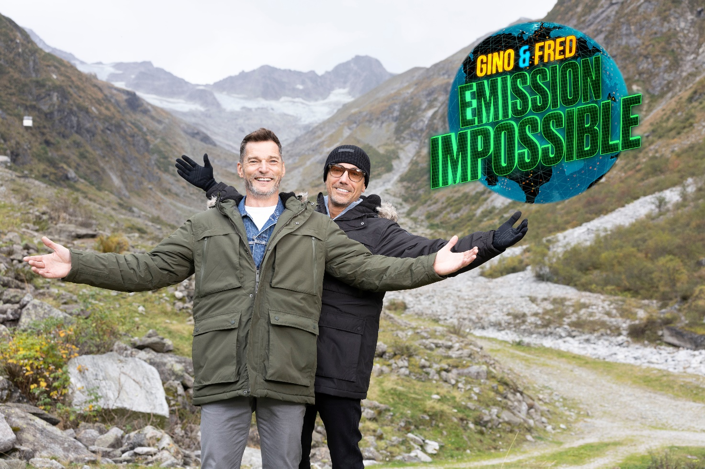

STRICTLY EMBARGOED UNTIL THURSDAY 5TH DECEMBER 2024

GINO & FRED: EMISSION IMPOSSIBLE
PRESS PACK

The firm Italian and French friends, Gino D'Acampo and Fred Sirieix are back on their travels. In an attempt to be greener they’re off on a geographical, culinary, cultural and eco-friendly tour of Austria and Croatia.

Taking in the Alps, spectacular but melting glaciers, vegan food alternatives, green safaris, agrotourism and lagoon aged wine, they are on a voyage of discovery.

Living la Dolce Vita comes at a cost to the planet, but will milking a donkey and eating fake salmon be enough for Gino and Fred to shake off their eco-sceptic attitudes and green up their acts?

TX Monday 16 and Tuesday 17 December at 9pm on ITV1, with both episodes available on ITVX

SERIES SYNOPSIS

Gino D'Acampo and Fred Sirieix are off on an epic eco-friendly trip, exploring the cuisine and culture of Austria and Croatia in an attempt to be greener. Living la Dolce Vita comes at a cost to the planet, so Gino and Fred are greening up their act and shaking off the eco-sceptic attitude on a journey of environmental discovery, meeting people and visiting locations that inspire them on a rip-roaring food odyssey.

Episode One
They start their journey in the Zillertal Alps in Western Austria, surrounded by beautiful but tragically melting glaciers. Despite Austrian beef being some of the most sustainable in the world, one of the biggest factors of climate change is the production of meat. In the shadow of the melting glacier they give vegetarian goulash a go and Gino declares himself a convert, vowing to start ‘meat free Mondays’ across his restaurants. After rowing through the Hinterlux glacier (over four kilometres wide and almost three times the size of Monaco) they try their hand at serving beer and dancing the Schuplatter, a traditional folk dance, at The Tiroler Abende in Innsbruk. Moving on to the Capital Vienna, their quest to find alternative food, goes via a 3D printer and ends with some innovative culinary options at a snail farm.

Episode Two
Heading to Croatia for the second episode, Gino and Fred are shocked by the ‘over-tourism’ in holiday hotspot and UNESCO World Heritage site, Dubrovnik. With packed streets, there are an estimated 36 tourists per one resident. Moving from the main old town to the Gruz harbor, they set off on a green safari, which sees Fred pop on the marigolds for a clean-up mission. As they continue their journey as ‘conscientious travellers’ they head out of the city to Mali Ston, a bay with world renowned shellfish, water polo and lagoon stored wine. Recovering from their water polo hopes being dashed by a group of expert locals, they head off to road test Croatia’s answer to sustainable travel – Agrotourism – as well as some donkey milk. Finally, Gino and Fred cross the Adriatic, landing on Gubavač for an off-grid adventure, but will the pair cope without their luxuries and each other’s company?

INTERVIEW WITH FRED SIRIEIX AND GINO D’ACAMPO

How would you describe Emission Impossible?
Fred: It’s just me and Gino, we love travelling and we decided to go to Austria and Croatia. In doing so we wanted to explore the possibility of travelling as green as we could. We were intending to travel as sustainably as we could, exploring the issue of sustainability and how global warming is affecting the planet and how it's going to affect the way we travel and the way we eat. Along the way we meet all sorts of people, whether they are involved in the climate change business or not. It's just us travelling around these two countries.

Why did you pick these two locations?
Fred: We chose them because Austria is a mountainous country with the Alps, of course. And Croatia because obviously it's a very coastal country, so to look at the effect of climate change in the mountains as well as near the sea.

Gino: I think the idea was for us to really understand, is it difficult to be environmentally friendly? Or is it something easy that we could all do? I think that was the main thing because whenever you hear about being environmentally friendly, everybody thinks, "Oh, no, I'm going to have to walk everywhere, bike everywhere.” We wanted to also see what kind of infrastructures we have in place at the moment to be as green as possible. That is the reason we went to Austria. Their infrastructure in the city, with electric bikes and electric cars, everything, it’s incredible, and something that we should learn. That’s the reason we went there - we went to Croatia and Austria to try to pick up tips so then we can bring them here in the UK and say, "Look guys, we tried this and it really works.”

What did you think of Croatia and Austria?
Fred: We really enjoyed it.

Gino: I had never been to either of them. I think both of them are very charming places, very well organized. Austria is super, super organised. Everything is very nice. Croatia is more like an Italian holiday because you got the sun, you got the sea, they're more relaxed. Although they blame the Italian people for all the rubbish washing up on their beaches.

Fred: Yeah. All the plastic that's being thrown in the sea - the currents are just taking this plastic onto the Croatian coast. In Croatia we met this woman who was doing this green safari, you go on the boat and basically, she takes you to an island and she shows you the disaster.

Gino: It’s covered in rubbish. Guys, we went onto islands covered with plastic.

Have you made changes at home to be more environmentally friendly?
Gino: Yes, I did. Well, first of all, let me start by saying that although many people would believe that I am not an environmentally friendly guy, I do have a house in Italy where we are 90% environmental. I produce my own electricity, I have my own water.

Fred: Well, I drive an electric car at home, I made the switch four years ago. You need to produce the car, you need to charge it anyway, so I'm not sure really if it's doing something, but I think it's helping with the environment and the emissions. I don't buy, for example, fruit and vegetables from supermarkets that are in plastic. I go to my local shops to do all my shopping, and I recycle as much as I can. I do wonder where the recycling bins go though. Where do they go? Is this rubbish processed? If I separate them into the right bin but they go somewhere and it incinerates it, what's the future there?

Were there any funny moments during filming?
Fred: What was very funny, Gino did not sleep well one day and he was very upset, he was in a very bad mood. I know Gino, if he's in a bad mood, I just say, "Gino is in a bad mood. Leave him alone. He's tired. He didn't sleep very well." He was in a bad mood. Then we had to cross on a ferry to go to this island, and I went to the toilet just before the ferry was supposed to dock. So I was late, and then Gino was in the car, but people were beeping because the car couldn't move, I had the keys!

Gino: Oh, yeah. He went to the toilet and he left me there, no keys or anything. I’m on the roof going, "It's not my fault."

Fred: He was furious. He got on top of the car shouting, "Fred, Fred, Fred." After that, he felt better. He needed to just release his tension and the frustration inside him, and then he was better.

You got to play water polo with players in Croatia, what was that like, especially for you Gino as you were roped in?
Gino: Even for Mr. Superman here, it was so hard. The waves were strong.

Fred: These guys are professionals. Even the guy who's 70 years old, he's been playing all his life. That's what they do. It's a national sport. It's like you playing football with Ronaldo or Zidane. You can't win!

Gino: We had no chance in hell!

Fred: But it was a good experience, the setting, the beach, how the club was. It was fair play for trying. I think when Gino saw the old guy, he was like, "Oh."

Gino: I was a bit annoyed because I was like, "Oh, he's an old man."

Fred: You see, the Croatians, they're very tall, they're big, they're strong, they're not like us. We have a much smaller frame than them.

In Austria you look at alternative foods, like 3D printed salmon, do you think that’s where we are headed if we don’t change our ways?
Fred: To eat 3D printed salmon, I did find it difficult to compute. Now, of course we could use insects which in terms of carbon footprint is negligible compared to beef. To go there, you have to challenge your culture and where you come from and what you consider acceptable. If you go to Thailand, for example, there are markets where there's just insects and people eat them. They've been eating them for generations and generations. As the population is shooting up across the world and you need to feed everybody on the planet, then we're going to have to make choices here. I think what will force us is necessity. Necessity will force us. We will be in front of a wall and there will be nowhere to go, we will have to change then.
You both come from the hospitality world. What would you be like if you were working together in that environment?
Gino: He would be outside and I would be inside? He's a pain in the ass in the restaurant!
Fred: We’re on a par l! I think the restaurant would run well, I don't have any doubt about that.

Gino: I think the bar would suffer with me and him in the restaurant. Someone will start to say, "Who's drinking all this champagne? Who's drinking all this Prosecco and the beer?" No. I think it would be quite cool. You like to do certain things in a certain way, which is great. In restaurants you have to have discipline.

You’ve looked at the eco side of travel. Are there any other areas that you want to explore alongside travel and cuisine?
Fred: Well, it's the people. It's the people that you meet and the culture of the places because you learn a lot. We meet some fascinating people, people we would never meet if we would stay here. We like that.

Gino: I think Emission Impossible is giving us the chance to do more of these shows - the idea that we don't want to go there to try to save the world. I'm not forcing it down people’s throats to say, "Oh, you shouldn't do this, or you should." No, no, no, no. Let's remind everybody why we do it.

Fred: Well, the thing is, it's about everybody's conscience, but at the end of the day, if you want something to change, there has to be someone somewhere who says, "Sorry mate, you can't do that."

ENDS

