**EMBARGOED UNTIL 00.01AM WEDNESDAY 4TH DECEMBER 2024**

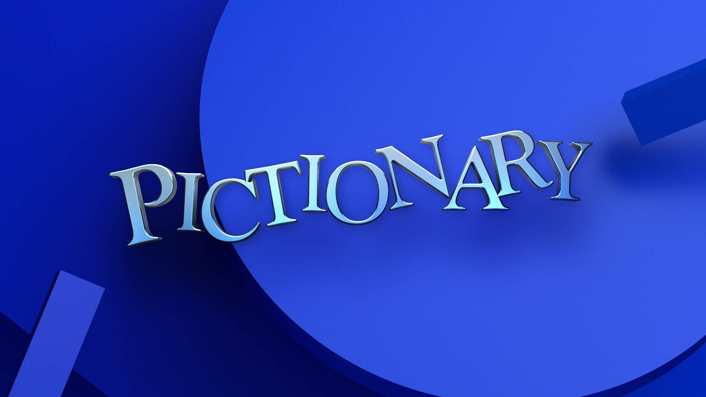

Unit still of Mel Giedroyc to follow.

**PICTIONARY SERIES 1**

**MEL GIEDROYC PRESS PACK**

**Mel Giedroyc** hosts the world’s most popular drawing game *Pictionary* for ITV1 and ITVX. Based on Mattel’s popular board game of quick-fire sketches and hilarious guesses, *Pictionary* will follow the same rules as the familiar at-home game and will see two teams battle against each other. In the classic sketching and guessing game Mel will be joined by two celebrity team captains who will lead their teams of contestants. Their mission is to draw images to match a word or phrase from a specific category and the teammates will have to guess correctly to score. The show proves you don’t have to be an artist to draw and in fact, if you can’t draw, it makes it even funnier! With the chance to win an incredible prize, the stakes are high…

For more information, please contact: [abigail.johnson@multitudemedia.co.uk](mailto:abigail.johnson@multitudemedia.co.uk) and [taffie.rwapunga@multitudemedia.co.uk](mailto:taffie.rwapunga@multitudemedia.co.uk)

You can download the series image here.

***Pictionary* is a brand-new series for ITV, how excited are you to be hosting it and how did it come about?**

I’ve long been a huge fan of the game and it’s something we’ve played forever in our family. I was so thrilled to be asked by ITV and Whisper North to do this gig!

**Audiences will likely be familiar with the game itself but are you able to explain how the show will work?**

It’s fiendishly simple. You’re given a word (in secret) and you have to draw it within a specific time, and your team members have to guess what it is that you’ve attempted to draw. Simple!!

***Pictionary* is already a popular family drawing game that many play at home. How do you think the game will translate to TV?**

To be honest that’s exactly what our show feels like – a game we’re playing at home. I hope that viewers will feel like they’re literally joining us in my cosy drawing room, with the greatest bunch of people playing.

**Can you tell us a bit about what we can expect from the new series?**

It’s very free flowing and there are a lot of laughs. We have a brilliant array of celebrity team captains playing along with our contestants. I think it’s safe to say that everybody had a really good time. It’s impossible not to get totally involved in the game. And hilarious to see everybody getting genuinely invested and competitive.

**How would you describe it in three words?**

MOST FUN EVER !!

**The new series of *Pictionary* will also feature celebrity captains, do you have any fun stories from filming that you can share with us?**

Each captain brought such energy and fun. They got hilariously competitive. **Laurence Llewellyn-Bowen** can draw and conduct at the same time; **Scarlett Moffatt** is a stealth drawer; **Jeff Brazier** is a great captain and should probably manage the England football team; **Hayley Tamaddon** did everything on tiptoes; **Eddie Kadi** and **Jeanette Kwakye** were an absolute hoot and of course, being an Olympic sportswoman, Jeanette brought her A game to the Pictionary Podium. She was explosive!

**If you were to play *Pictionary* yourself, who would you want on your team?**

I was going to say Picasso but he’d be too abstract maybe. I’d like Alex Horne and Sue Perkins, I think. They would bring their lateral brains and excellent drawing skills to the fore.

**How good are you at drawing?**

Beyond terrible. But I’m an enthusiastic guesser and get ridiculously competitive, so I think that would carry me through.

**If you had to draw one thing to describe *Pictionary*, what would you draw?**

I’d draw a (terrible) stick person with a pen in their hand, then a plus sign, then a little team of people cheering them on. What am I saying? I’d never manage that in thirty seconds. I’d jump up and down a lot, draw a big pencil and point to it with increasing fervour and excitement.

**Why do you think families will love this show?**

I think it will feel familiar and fun. Just like playing the game in your own home. I imagine there will be a lot of howling at the TV screen along the lines of “WHAAAAAAAAT???? THAT DOESN’T LOOK LIKE ANYTHING LIKE A TOMATO????!!!” The atmosphere in the studio was very relaxed and verged on the hysterical at times. I hope that viewers will find it a totally fun and easy watch.

***Pictionary* has two Christmas specials this year, can you tell us a bit about those and what to expect? How does it differ from the series we will watch in January?**

It will have the great excitement of it being Christmas; hopefully a feeling of real fun and Christmas togetherness in the studio, and a lot more tinsel and decorations around the place. I cannot tell you how much fun we had making this show. Captains and contestants alike were so up for it, and I really hope that this comes across at home.

**How will you be spending your Christmas and New Year this year?**

I love Christmas and am massively looking forward to it this year. The big ‘neighbours get-together’ drinks are at ours this year. Then we have seven great-nieces and nephews added to the clan now, so we’re doing a big (chaotic) family get-together at ours with everybody, Christmas meals at ours and my sister’s big Boxing Day walk and a lot of christmas telly watching – I hope!

**And do you have a favourite game that you all like to play at Christmas time?**

We have a full-size cutout of Ainsley Harriott (my kids used to be obsessed with him) and our favourite Christmas game is to sneak the cutout around the house into various rooms and surprise whoever is in them with it. Utterly ridiculous, utterly puerile, great fun. We also play a game called The Phantom which is terrifying and too long and complicated to explain here…